# **Web Development (Module - 4 CSS & CSS3)**

**(Q.1)** **What are the benefits of using CSS?**

**(ANS):**

CSS, or Cascading Style Sheets, is a style sheet language used for describing the presentation of a document written in HTML or XML. Here are several benefits of using CSS in web development:

1. ***Separation of Content and Presentation:***

* CSS allows for a clear separation between the structure (HTML) and the presentation (CSS) of a web page. This makes it easier to manage and maintain web pages, as changes to the design can be made without altering the underlying content.

1. ***Consistency:***

* With CSS, you can apply consistent styles across multiple pages of a website. This ensures a uniform look and feel, making navigation and user experience more predictable and user-friendly.

1. ***Ease of Maintenance:***

* Centralizing the styling information in external CSS files makes it easier to update and maintain the design of a website. Changes made in the CSS file are automatically applied to all pages linked to that file, reducing redundancy and making updates more efficient.

1. ***Flexibility:***

* CSS provides a high degree of flexibility in terms of layout and design. It allows for responsive design, enabling web pages to adapt to different screen sizes and devices. Media queries in CSS can be used to apply styles based on the characteristics of the device, such as width, height, or resolution.

1. ***Reusability:***

* CSS allows for the creation of style rules that can be reused across different elements or pages. This promotes modular design and reduces the need to duplicate styling information, contributing to more maintainable and scalable code.

1. ***Load Time and Performance:***

* By separating style information into external CSS files, you can reduce the size of HTML files, leading to faster load times for web pages. This can improve the overall performance of a website, particularly important for users on slower internet connections or mobile devices.

1. ***Search Engine Optimization (SEO):***

* Well-structured and semantically meaningful HTML, combined with proper CSS, can contribute to better search engine rankings. Search engines tend to favor clean and accessible code, and CSS helps achieve this by promoting a separation of concerns.

1. ***Accessibility:***

* CSS supports the creation of accessible and user-friendly designs. It allows for the use of semantic HTML combined with styles, making content more accessible to people with disabilities and improving overall usability.

1. ***Print-Friendly Styles:***

* CSS can be used to create print styles, allowing web developers to define how a page should appear when printed. This helps ensure a better print experience for users who may want to print content from the website.

In summary, CSS offers numerous benefits in terms of maintainability, flexibility, consistency, and overall design control in web development. It plays a crucial role in creating visually appealing and functional websites.

**(Q.2) What are the disadvantages of CSS?**

**(ANS):**

While CSS offers numerous advantages in web development, it also has its challenges and potential disadvantages. Here are some of the drawbacks associated with using CSS:

1. ***Cross-Browser Compatibility:***

* Ensuring consistent rendering of styles across different web browsers can be challenging. Browsers may interpret CSS rules differently, leading to discrepancies in the appearance of a website. Developers often need to use browser-specific hacks or workarounds to address these issues.

1. ***Learning Curve:***

* CSS, especially as web development becomes more complex and incorporates newer features, can have a steep learning curve for beginners. Understanding the intricacies of CSS, including positioning, layout models, and responsiveness, may require time and practice.

1. ***Global Scope:***

* CSS operates in a global scope, which means that styles defined for one part of a page can inadvertently affect other parts. This can lead to unintended consequences and make it challenging to isolate styles for specific elements.

1. ***Lack of Strong Typing:***

* CSS is not a strongly typed language, meaning there is no strict control over the data types used in style rules. This lack of typing can lead to errors that may be challenging to debug, especially in larger projects.

1. ***Limited Layout Control:***

* Achieving complex layouts or fine-grained control over elements can sometimes be challenging with CSS. Although CSS has evolved to offer more advanced layout options, some designs may still require workarounds or be difficult to implement.

1. ***Performance Impact:***

* Poorly optimized or overly complex CSS files can impact the performance of a website. Large CSS files may increase page load times, especially on slower internet connections or less powerful devices.

1. ***Versioning and Vendor Prefixes:***

* CSS properties sometimes require vendor prefixes to ensure compatibility with different browsers. Managing these prefixes and keeping track of the latest specifications can be cumbersome and may result in redundant or outdated code.

1. ***Limited Dynamic Capabilities:***

* While CSS has become more powerful with features like animations and transitions, it is still primarily a styling language and lacks the dynamic capabilities of scripting languages like JavaScript. Complex interactions and dynamic changes often require additional scripting.

1. ***Debugging Challenges:***

* Debugging CSS issues can be challenging, especially when dealing with complex layouts or intricate style rules. Identifying the source of styling problems and resolving them can be time-consuming.

Despite these disadvantages, it's important to note that many of these challenges can be mitigated with good development practices, proper testing, and ongoing education in CSS best practices. Additionally, advancements in web standards and browser compatibility have improved the overall experience of working with CSS.

**(Q.3) What is the difference between CSS2 and CSS3?**

**(ANS):**

CSS (Cascading Style Sheets) is a stylesheet language used for describing the presentation of a document written in HTML or XML. CSS evolves over time, and different versions introduce new features and improvements. CSS2 and CSS3 are two major versions of the CSS specification, each bringing its own set of enhancements. Here are the key differences between CSS2 and CSS3:

1. ***Modules and Selectors:***

* **CSS2:** It was a monolithic specification that introduced basic styling features. Selectors and properties were relatively limited compared to later versions.
* **CSS3:** It is modular, meaning it is divided into smaller, more focused modules, each addressing specific aspects of styling. This modularity allows for more granular updates and easier integration of new features.

1. ***Media Queries:***

* **CSS2:** Did not include media queries, which are essential for responsive web design.
* **CSS3:** Introduces media queries, allowing styles to be applied based on characteristics of the device, such as screen size, resolution, or orientation. This is crucial for creating responsive and adaptive designs.

1. ***Selectors:***

* **CSS2:** Introduced a basic set of selectors, including element selectors, class selectors, and ID selectors.
* **CSS3:** Expanded the selector capabilities with advanced selectors such as attribute selectors, pseudo-classes (:nth-child, :not, etc.), and pseudo-elements (::before, ::after, etc.). This enhances the ability to target and style specific elements.

1. ***Box Model:***

* **CSS2:** Defined the basic box model, including properties like width, height, margin, padding, and border.
* **CSS3:** Provides additional features such as box-sizing (to control how width and height are calculated), box-shadow (for adding shadows to boxes), and border-radius (for creating rounded corners).

1. ***Flexbox and Grid Layout:***

* **CSS2:** Did not have dedicated features for flexible box layouts or grid layouts.
* **CSS3:** Introduces Flexbox and Grid Layout modules, offering powerful tools for creating complex and responsive layouts. Flexbox is designed for one-dimensional layouts (e.g., rows or columns), while Grid Layout is designed for two-dimensional layouts.

1. ***Transitions and Animations:***

* **CSS2:** Did not include built-in support for transitions or animations.
* **CSS3:** Introduces the transition property for smooth transitions between states and the @keyframes rule for defining animations. This allows developers to create more dynamic and interactive user interfaces.

1. ***Multi-column Layout:***

* **CSS2:** Did not provide a standardized way to create multi-column layouts.
* **CSS3:** Introduces the multi-column layout module, allowing content to flow into multiple columns, improving the presentation of text and making better use of available space.

1. ***Typography:***

* **CSS2:** Had basic typography features, such as font-family, font-size, and text-align.
* **CSS3:** Expands typography options with features like @font-face (for custom fonts), text-shadow, word-wrap, and hyphens, providing more control over text rendering.

These are just a few examples of the differences between CSS2 and CSS3. CSS3 represents a significant advancement over CSS2, offering web developers a broader set of tools for creating modern and feature-rich web designs. It's important to note that CSS is an evolving standard, and new features may continue to be added in future specifications.

**(Q.4) Name a few CSS style components.**

**(ANS):**

CSS style components, often referred to as style rules or properties, are used to define the visual appearance of HTML elements. Here are a few CSS style components:

1. ***Color:***

* **color:** Sets the text color.
* **background-color:** Sets the background color of an element.

1. ***Typography:***

* **font-family:** Specifies the font for text.
* **font-size:** Sets the size of the font.
* **font-weight:** Defines the thickness of the font.
* **line-height:** Sets the height of a line of text.

1. ***Layout:***

* **width and height:** Sets the dimensions of an element.
* **margin and padding:** Defines the space around and within an element.
* **display:** Specifies how an element is displayed (e.g., block, inline, flex).

1. ***Border:***

* **border:** Combines the properties for setting border width, style, and color.
* **border-radius:** Creates rounded corners.

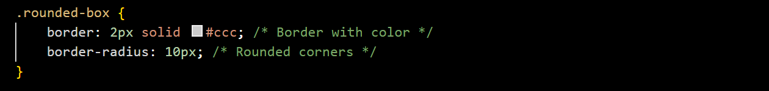

1. ***Positioning:***

* **position:** Specifies the positioning method (e.g., relative, absolute, fixed).
* **top, right, bottom, left:** Sets the position of an element.

1. ***Flexbox:***

* **display: flex:** Turns an element into a flex container.
* **flex:** Specifies the ability of a flex item to grow or shrink.

1. ***Box Shadow:***

* **box-shadow:** Adds a shadow effect to an element.



These are just a few examples of the many CSS style components available for defining the appearance of web elements. The combination of these components allows developers to create diverse and visually appealing designs.

**(Q.5) What do you understand by CSS opacity?**

**(ANS):**

CSS opacity is a property that controls the transparency or opacity level of an element in a web page. It allows you to make an element partially transparent, revealing the content beneath it. The opacity property takes a value between 0 and 1, where 0 represents complete transparency (invisible), and 1 represents full opacity (completely visible).

Here's the basic syntax for using the opacity property:



For example:



In this example, the .transparent-box class will make the associated element 50% transparent, allowing the content beneath it to show through.

It's important to note a few things about the opacity property:

1. ***Inheritance:***

* The opacity property is inherited by child elements. If you set the opacity of a container, its child elements will also inherit the same opacity level.

1. ***Affects All Descendant Elements:***

* Unlike certain other CSS properties, opacity affects not only the background but also all the content (including text and child elements) within the element. If you only want to make the background semi-transparent, other techniques like using RGBA colors or background transparency might be more appropriate.

Here's an example of how you might use opacity in HTML and CSS:

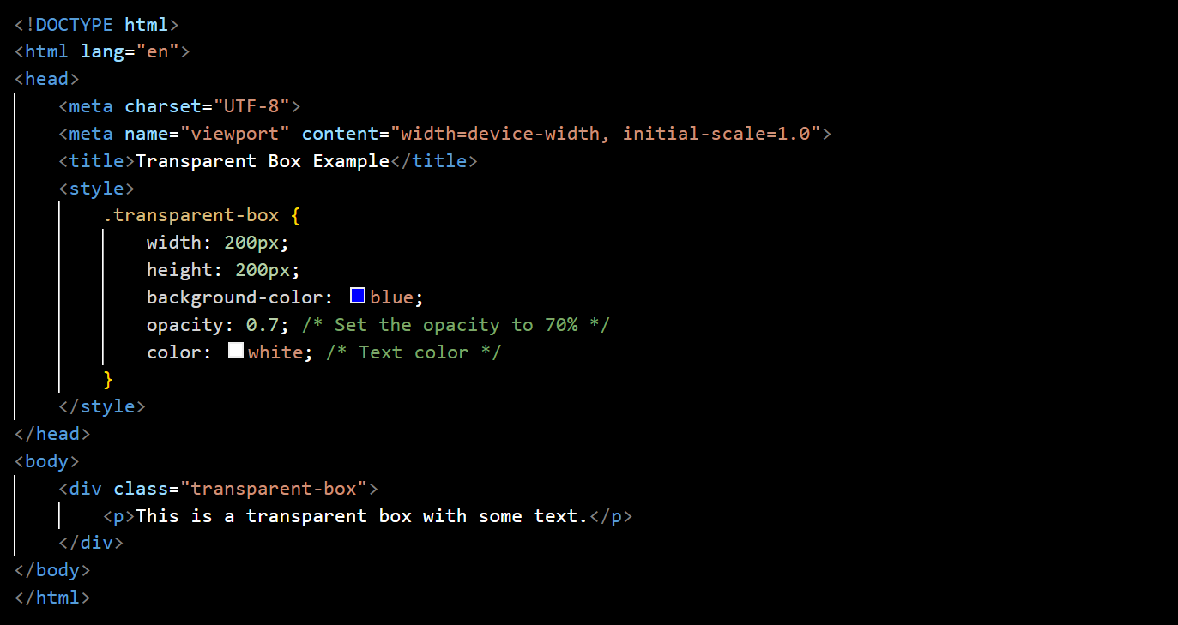

In this example, the .transparent-box div has a blue background with 70% opacity, making it semi-transparent and allowing the text inside to be partially visible.

**(Q.6) How can the background color of an element be changed?**

**(ANS):**

To change the background color of an element in HTML using CSS, you can use the background-color property. Here's the basic syntax:



* **selector:** This is the HTML element or class/id selector for which you want to change the background color.
* **colorValue:** This can be a specific color name (e.g., "red"), a hexadecimal color code (e.g., "#ff0000" for red), an RGB value (e.g., "rgb(255, 0, 0)"), or an RGBA value (e.g., "rgba(255, 0, 0, 0.5)" for red with 50% opacity).

Here are a few examples:

1. ***Using a Color Name:***



1. ***Using a Hexadecimal Color Code:***



1. ***Using an RGB Value:***



1. ***Using an RGBA Value (with Opacity):***



1. ***Using the background Shorthand:***



Remember to replace ".element" with the actual selector for the HTML element you want to style.

Here's an example in HTML:

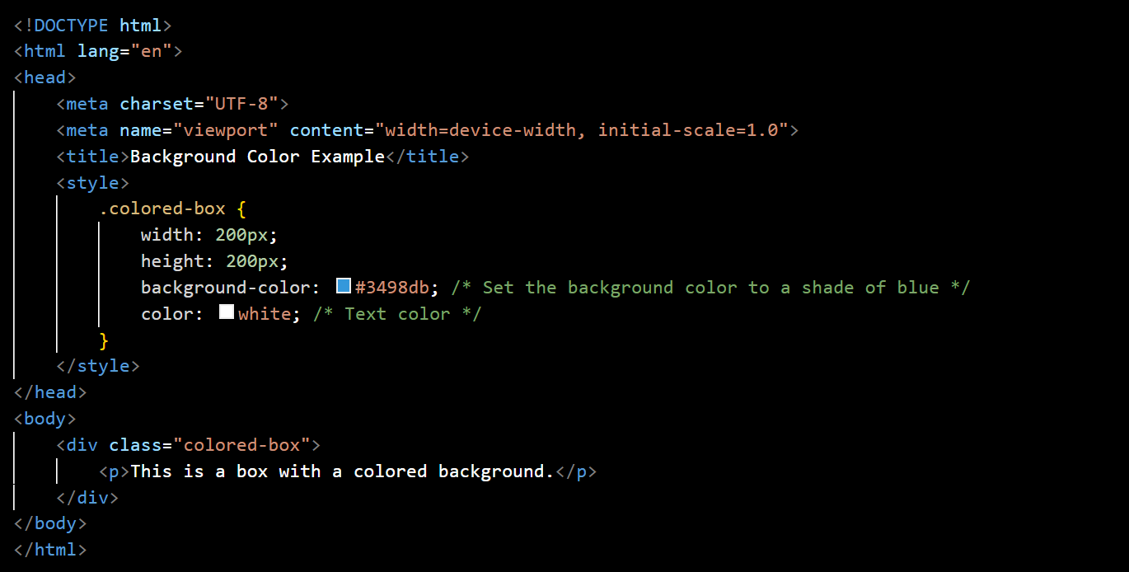

In this example, the background color of the .colored-box div is set to a shade of blue using the background-color property.

**(Q.7) How can image repetition of the backup be controlled?**

**(ANS):**

To control the repetition of a background image in CSS, you can use the background-repeat property. This property allows you to specify whether and how a background image should repeat in both the horizontal (x-axis) and vertical (y-axis) directions. The values you can use are:

1. ***repeat (default):*** The background image is repeated both horizontally and vertically.



1. ***repeat-x:*** The background image is repeated only horizontally.

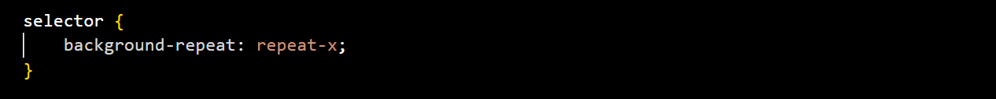

1. ***repeat-y:*** The background image is repeated only vertically.



1. ***no-repeat:*** The background image is not repeated.



Here's an example with HTML and CSS:

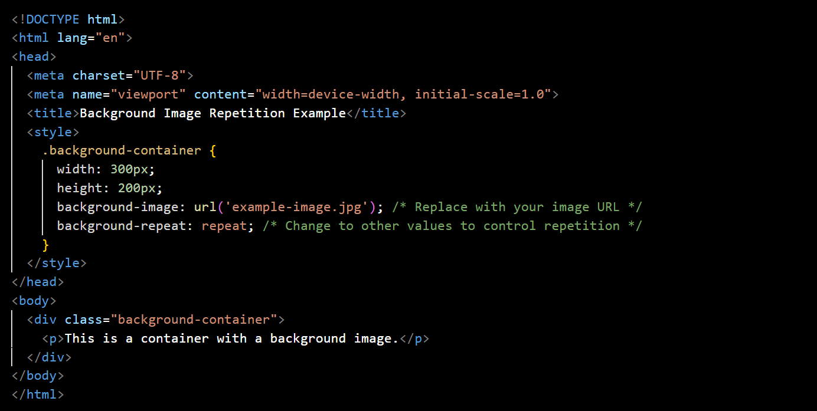

In this example, the .background-container div has a background image specified using the background-image property. The repetition of the background image is controlled by the background-repeat property, which is set to repeat by default. You can experiment with other values to achieve the desired effect for your background image.

**(Q.8) What is the use of the background-position property?**

**(ANS):**

The background-position property in CSS is used to control the placement of a background image within its containing element. It allows you to specify the horizontal and vertical position of the background image. The property takes two values:

* The first value represents the horizontal position.
* The second value represents the vertical position.

The values can be specified using keywords (such as left, center, right, top, bottom) or length units (such as pixels or percentages). Here is the basic syntax:



Here are some examples:

1. ***Using Keywords:***



1. ***Using Length Units:***



1. ***Combining Keywords and Length Units:***

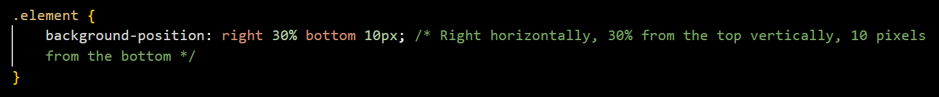

1. ***Percentages:***



By default, if only one value is specified, the second value is assumed to be center. If no values are specified, the default is 0% 0% (top-left corner).

Here's a simple example in HTML and CSS:

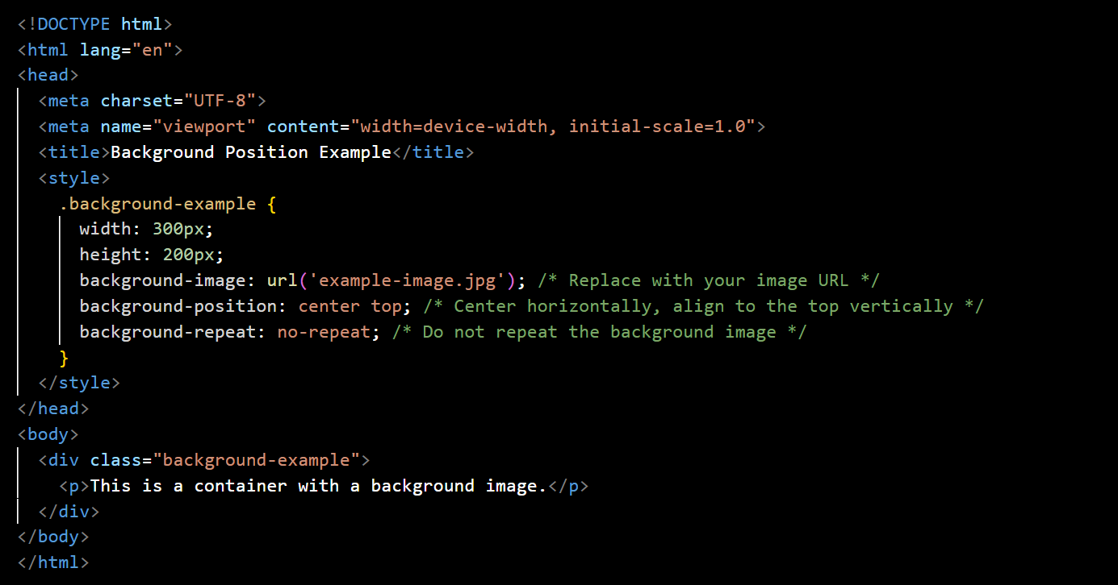

In this example, the .background-example div has a background image, and the background-position property is used to center the image horizontally and align it to the top vertically. The background-repeat property is set to no-repeat to prevent the image from repeating.

**(Q.9) Which property controls the image scroll in the background?**

**(ANS):**

The property that controls the scrolling behavior of a background image in CSS is the background-attachment property. This property allows you to specify whether the background image should scroll with the rest of the content or if it should remain fixed as the user scrolls down the page.

The background-attachment property can take one of the following values:

1. ***scroll (default):*** The background image will scroll along with the content as the user scrolls down the page.



1. ***fixed:*** The background image will remain fixed relative to the viewport, and it will not scroll with the content.



1. ***local:*** The background image will scroll with the element's contents. This is less commonly used and might not be supported in all browsers.



Here's a simple example in HTML and CSS:

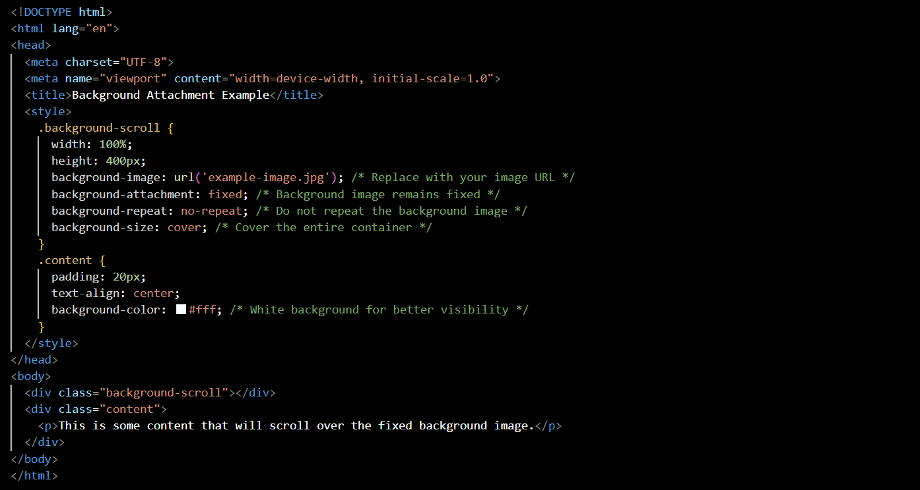

In this example, the .background-scroll div has a fixed background image, and the content in the .content div will scroll over the top of the fixed background. Adjust the background-attachment property as needed for your design.

**(Q.10) Why should background and color be used as separate properties?**

**(ANS):**

Using background and color as separate properties in CSS allows for greater flexibility and control over the styling of elements. While the background shorthand property combines various background-related properties into a single declaration, separating background and color provides the following advantages:

1. ***Modularity and Readability:***

* Separating background and color into distinct properties makes the code more modular and easier to read. Each property is responsible for a specific aspect of styling, making it clearer for developers to understand and maintain.

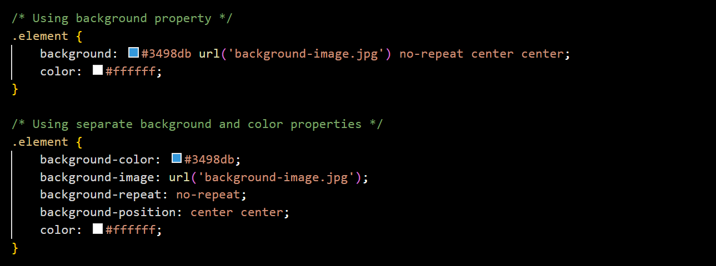

1. ***Fine-Tuned Control:***

* Separating background and color allows for more granular control over each aspect. For example, you can adjust the background color without affecting the background image, or vice versa.

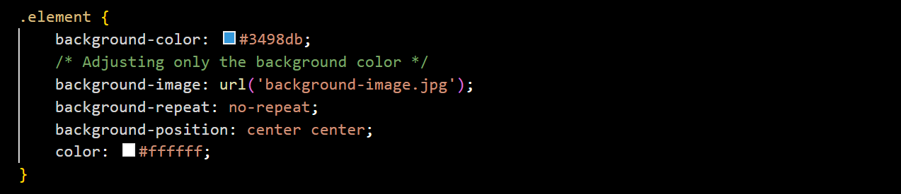

1. ***Override and Inheritance:***

* When properties are separated, it becomes easier to override or inherit specific styles. This is especially useful when dealing with complex stylesheets or when applying styles to specific elements.

1. ***Compatibility and Browser Support:***

* In some scenarios, using shorthand properties like background may not be supported consistently across all browsers, especially when dealing with newer CSS features. Separating properties ensures better compatibility.

1. ***Ease of Maintenance:***

* If you need to make changes to the background or color, having separate properties makes it more straightforward to locate and modify the relevant styles. This can be particularly important in larger projects with numerous styles.

In summary, while the background shorthand property can be convenient for simple cases, separating background and color provides more control, better readability, and ease of maintenance, especially in larger and more complex stylesheets. It also aligns with the principles of maintainability and separation of concerns in web development.

**(Q.11) How to center block elements using CSS1?**

**(ANS):**

CSS1, the first version of Cascading Style Sheets, was released in 1996. While it introduced fundamental styling capabilities, it did not include advanced layout properties like flexbox or grid, which make centering elements much simpler in modern CSS. However, you can still achieve centering of block-level elements in CSS1 using some techniques. One common method is to use a combination of the following:

1. ***Auto Margins:***

* Set left and right margins to auto for a block-level element. This works for horizontally centering the element within its containing block.

1. ***Text-Align:***

* For inline elements within the block-level element, you can use the text-align property on the parent block-level element and set it to center. This works for horizontally centering inline elements.

Here's an example:

In this example:

* The .container class uses text-align: center; to center the inline content (the <span> element) within it horizontally.
* The .centered-block class has left and right margins set to auto, making it horizontally centered within its containing block.

Keep in mind that this approach may not work as expected in all situations, especially if the block-level element has a fixed width. For more modern and flexible approaches to centering, consider using CSS2 or later versions with properties like flexbox or grid.

**(Q.12) How to maintain the CSS specifications?**

**(ANS):**

Maintaining CSS specifications involves staying informed about updates, best practices, and changes to the language. Here are some general strategies to help you stay up-to-date and effectively maintain CSS specifications:

1. ***Official Documentation:***

* Regularly refer to the official documentation provided by the World Wide Web Consortium (W3C) for CSS. The official specification documents are authoritative and provide in-depth information about the features, properties, and behavior of CSS.

1. ***W3C Website:***

* Visit the W3C website (https://www.w3.org/) for announcements, news, and updates related to web standards, including CSS. The W3C is the primary organization responsible for developing and maintaining web standards.

1. ***Blogs and Newsletters:***

* Follow blogs and newsletters of reputable web development communities, organizations, and experts. Many websites and individuals regularly publish articles and updates related to CSS and web standards.

1. ***CSS Working Group:***

* Keep an eye on the activities of the CSS Working Group, which is responsible for developing and maintaining CSS specifications within the W3C. The Working Group's mailing list and public discussions can provide insights into ongoing developments.

1. ***CSS Browser Support:***

* Stay informed about the latest updates and changes in browser support for CSS features. Browsers periodically release updates that may introduce new CSS capabilities or modify existing ones.

1. ***Online Communities:***

* Participate in online communities and forums where web developers discuss CSS and related topics. Platforms like Stack Overflow, Reddit (e.g., r/css), and specialized web development forums can be valuable resources for sharing knowledge and staying informed.

1. ***Books and Tutorials:***

* Read books and tutorials written by experienced web developers and authors. Books can provide in-depth explanations and practical insights into using CSS effectively.

1. ***Conferences and Events:***

* Attend web development conferences, workshops, and meetups. These events often feature sessions on the latest CSS trends, best practices, and upcoming specifications. Networking with other developers can also provide valuable information.

1. ***Version Control:***

* If you work on a team or on multiple projects, consider using version control systems like Git. This allows you to track changes to your CSS files, collaborate with others, and roll back changes if needed.

1. ***Continuous Learning:***

* Web development is a dynamic field, and continuous learning is essential. Stay curious, explore new features, and be open to adopting best practices as they evolve.

By combining these strategies, you can establish a solid foundation for maintaining and staying current with CSS specifications and best practices. Keep in mind that the web development landscape evolves, so ongoing learning and adaptation are key to success.

**(Q.13) What are the ways to integrate CSS as a web page?**

**(ANS):**

There are several ways to integrate CSS (Cascading Style Sheets) into a web page. The choice of method often depends on factors such as the project's requirements, development preferences, and the level of control needed over styling. Here are common ways to integrate CSS into a web page:

1. ***Inline Styles:***

* Inline styles involve applying styles directly within HTML elements using the style attribute. This method is suitable for individual elements but can become cumbersome when applied to multiple elements.



1. ***Internal Styles (Embedded Styles):***

* Internal styles involve placing CSS rules within a <style> element in the <head> section of an HTML document. This method is useful for applying styles to multiple elements within the same document.

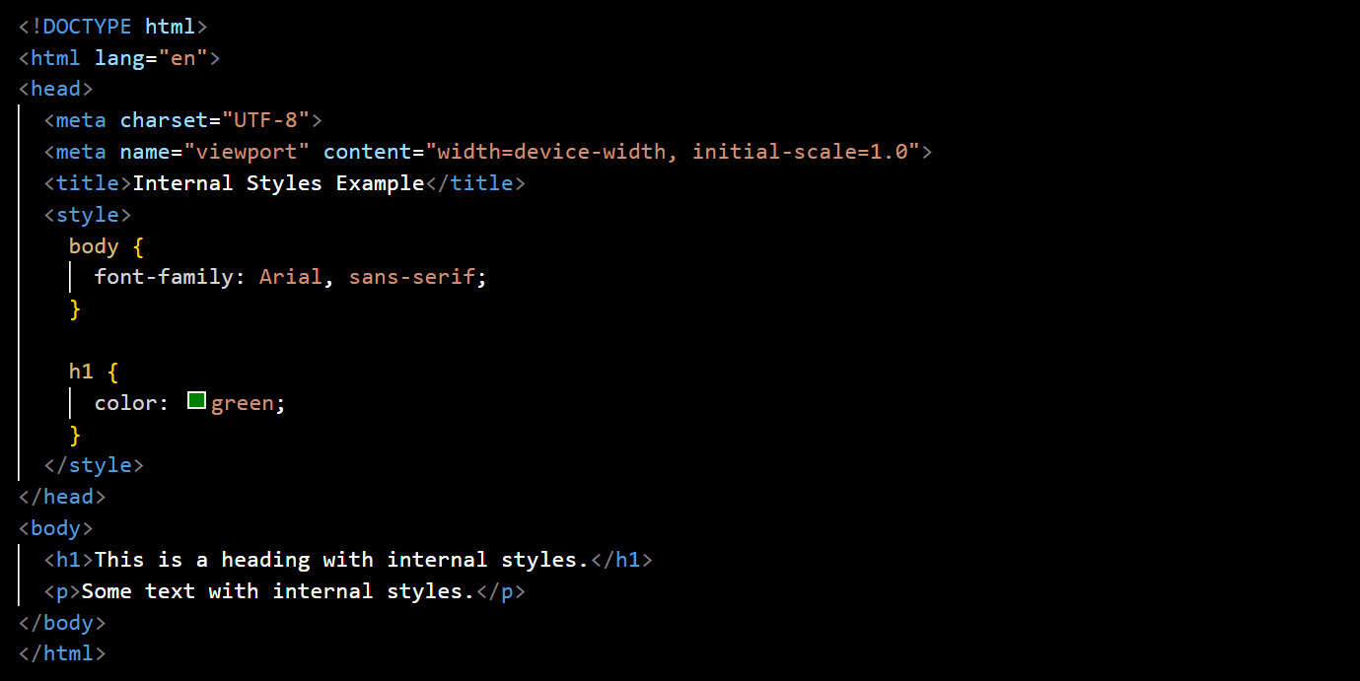

1. ***External Styles (Linked Styles):***

* External styles involve creating a separate CSS file and linking it to the HTML document. This method is beneficial for maintaining a consistent style across multiple pages.

styles.css:

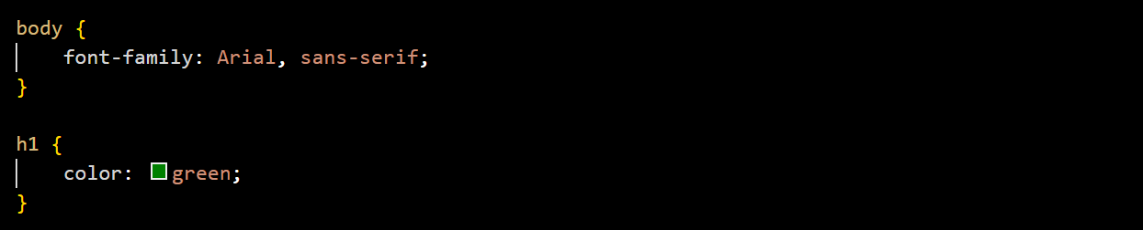

index.html:

1. ***Imported Styles (Using @import):***

* Styles can be imported from another CSS file using the @import rule within a style block. This method is similar to external styles but allows for more control over when styles are loaded.

main.css:



styles.css:

1. ***CSS-in-JS (JavaScript Libraries):***

* In modern web development, some projects use JavaScript libraries or frameworks that allow developers to write CSS directly within JavaScript files. This approach is often associated with component-based frameworks.

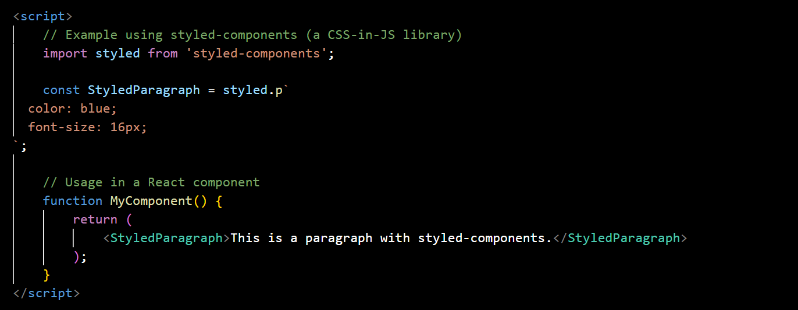

Choose the method that aligns with the project's structure, complexity, and maintainability requirements. Often, a combination of these methods is used depending on the context and needs of the web application.

**(Q.14) What is embedded style sheets?**

**(ANS):**

Embedded styles refer to the inclusion of CSS (Cascading Style Sheets) directly within an HTML document. This is achieved by using an internal or embedded style sheet. The styles are defined within a <style> element, which is placed in the <head> section of the HTML document.

Here's an example of an embedded style sheet:

In this example:

* The <style> element contains CSS rules that define the styling for various elements.
* The styles apply to the entire document (e.g., setting the font family and background color for the body element) as well as specific elements (e.g., changing the color of h1).

**Advantages of Embedded Styles:**

1. ***Convenience:*** Embedding styles directly within the HTML document is convenient for small projects or cases where the styling is specific to that particular document.
2. ***Isolation:*** Styles defined in an embedded style sheet are scoped to the document in which they are placed. This helps avoid unintentional styling conflicts with other parts of the website.
3. ***Readability:*** Having the styles close to the HTML markup can make the code more readable and easier to maintain, especially for simple projects.

However, for larger projects or scenarios where styles need to be shared across multiple pages, using external style sheets (linked styles) might be more practical. External style sheets offer better organization, easier maintenance, and the ability to apply consistent styles across various pages.

**(Q.15) What are the external style sheets?**

**(ANS):**

External style sheets are separate CSS (Cascading Style Sheets) files that contain style rules and are linked to HTML documents. These external style sheets provide a way to centralize and reuse styles across multiple pages within a website. By using external style sheets, you can maintain a consistent design, update styles in one place, and improve the overall organization of your project.

Here's how external style sheets work:

1. ***Create an External CSS File:***

* Write your CSS rules in a separate .css file. For example, you can create a file named styles.css.

styles.css:

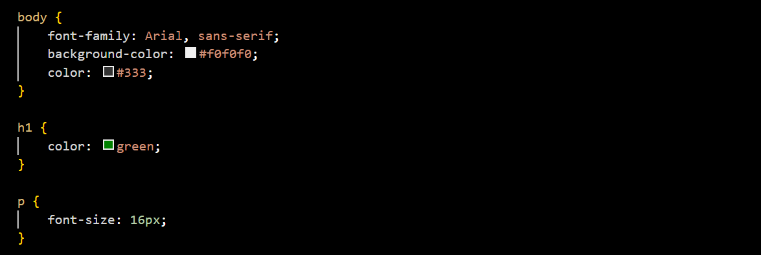

1. ***Link the External CSS File to HTML:***

* In your HTML documents, link to the external CSS file using the <link> element. Place this link in the <head> section of your HTML document.

index.html:

1. ***Benefits of External Style Sheets:***

* **Modularity:** External style sheets promote modularity by separating the structure (HTML) from the presentation (CSS). Each file can focus on its specific role.
* **Consistency:** Styles defined in an external style sheet can be reused across multiple HTML pages, ensuring a consistent look and feel.
* **Ease of Maintenance:** Updates or changes to the styling can be made in a single external CSS file, affecting all linked HTML pages. This simplifies maintenance and reduces redundancy.
* **Efficiency:** External style sheets can be cached by browsers, resulting in faster page loading for subsequent visits.

1. ***Multiple HTML Pages, One Style Sheet:***

* You can link the same external style sheet to multiple HTML pages. This approach ensures that changes made to the style sheet automatically apply to all linked pages.

another-page.html:

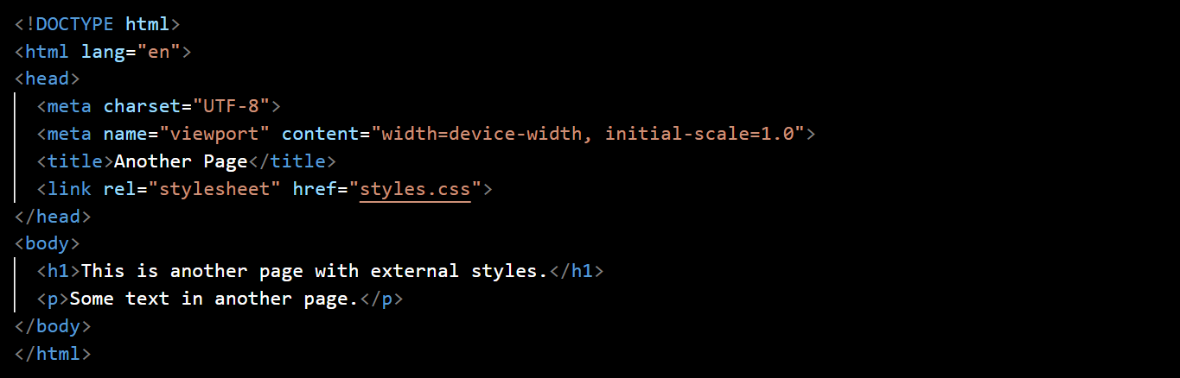

By using external style sheets, you can streamline your web development process and maintain a clean and organized structure for your CSS code.

**(Q.16) What are the advantages and disadvantages of using external style sheets?**

**(ANS):**

Using external style sheets in web development offers several advantages, but it also comes with some potential disadvantages. Let's explore both sides:

**Advantages of External Style Sheets:**

1. ***Modularity:***

* **Advantage:** External style sheets promote modularity by separating the structure (HTML) from the presentation (CSS). This separation enhances code organization and maintainability.

1. ***Consistency:***

* **Advantage:** Styles defined in an external style sheet can be reused across multiple HTML pages, ensuring a consistent look and feel throughout a website.

1. ***Ease of Maintenance:***

* **Advantage:** Updates or changes to the styling can be made in a single external CSS file. This centralized approach simplifies maintenance, reduces redundancy, and ensures changes apply to all linked HTML pages.

1. ***Efficiency:***

* **Advantage:** External style sheets can be cached by browsers. Once a user visits a page on a website, subsequent visits to other pages using the same style sheet can benefit from cached resources, resulting in faster page loading times.

1. ***Separation of Concerns:***

* **Advantage:** External style sheets adhere to the principle of separation of concerns, allowing developers to focus on specific aspects of a project. HTML handles structure, JavaScript handles behavior, and CSS handles presentation.

1. ***Global Changes:***

* **Advantage:** Making global changes, such as updating colors or font styles, is straightforward with external style sheets. A single modification in the CSS file affects all linked HTML pages.

1. ***File Reusability:***

* **Advantage:** External style sheets can be reused across different projects. This is particularly beneficial when using frameworks or libraries that follow a consistent style.

**Disadvantages of External Style Sheets:**

1. ***Additional HTTP Request:***

* **Disadvantage:** Each external style sheet requires an additional HTTP request, which can impact page loading times, especially on slower networks. However, this impact is often mitigated by browser caching.

1. ***Rendering Delay:***

* **Disadvantage:** The browser might delay rendering the page until the external style sheet is loaded, leading to a potential delay in the initial display of the page.

1. ***Dependence on File Availability:***

* **Disadvantage:** If the external style sheet fails to load (due to network issues or an incorrect file path), the associated HTML page may lack proper styling, leading to a less-than-optimal user experience.

1. ***Limited Local Modifications:***

* **Disadvantage:** External style sheets are shared across multiple HTML pages. While this promotes consistency, it can limit the ability to make local modifications specific to one page without creating additional styles.

1. ***Compatibility with Inline Styles:***

* **Disadvantage:** If both external styles and inline styles are used in the same document, conflicts or unexpected results may occur, as inline styles typically take precedence.

1. ***Learning Curve:***

* **Disadvantage:** For beginners or smaller projects, the concept of external style sheets may introduce a learning curve. Understanding how to organize and link files might be initially challenging.

In practice, the choice between inline styles, internal styles, and external style sheets depends on the project's specific requirements and development considerations. While external style sheets are widely used and beneficial for large projects, it's essential to weigh the advantages against potential drawbacks based on the context of the web development project.

**(Q.17) What is the meaning of the CSS selector?**

**(ANS):**

In CSS (Cascading Style Sheets), a selector is a pattern or a set of rules that define which elements in an HTML document will be targeted and styled. Selectors are a crucial part of CSS as they allow developers to apply styles to specific elements or groups of elements on a web page.

The basic syntax of a CSS rule consists of a selector followed by a set of declarations enclosed in curly braces. Here's a simple example:

In this example, the selector is h1, which means that the styles defined inside the curly braces will apply to all <h1> elements in the HTML document.

Types of Selectors:

1. ***Element Selector:***

* Selects all instances of a specific HTML element. Example: p selects all paragraphs.



1. ***Class Selector:***

* Selects elements with a specific class attribute. Example: .highlight selects all elements with the class "highlight."

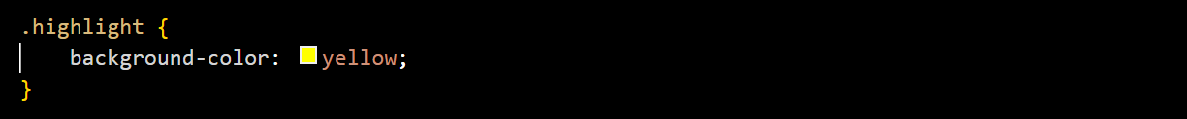

1. ***ID Selector:***

* Selects a single element with a specific ID attribute. Example: #header selects the element with the ID "header."

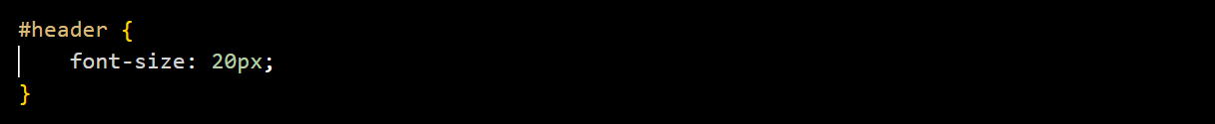

1. ***Attribute Selector:***

* Selects elements based on the presence or value of their attributes. Example: [type="text"] selects all input elements with the attribute type set to "text."

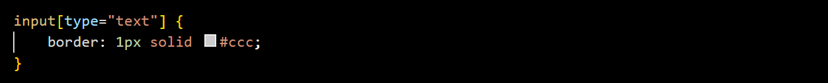

1. ***Descendant Selector:***

* Selects an element that is a descendant of another specific element. Example: article p selects all <p> elements that are descendants of an <article> element.

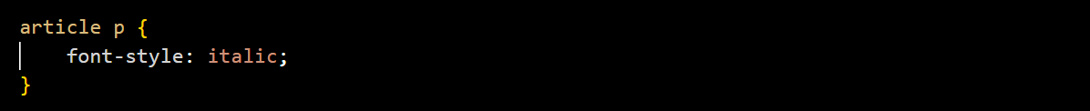

1. ***Child Selector:***

* Selects an element that is a direct child of another specific element. Example: ul > li selects all <li> elements that are direct children of a <ul>.



These are just a few examples of the many CSS selectors available. Selectors play a crucial role in determining which HTML elements will be styled and how they will be styled. They provide the means to target elements precisely and apply styling rules according to the desired criteria.

**(Q.18) What are the media types allowed by CSS?**

**(ANS):**

Media types in CSS are used to specify the target devices or media on which a document is being displayed. They allow you to apply different styles based on characteristics such as screen size, device capabilities, or the type of output device. The @media rule is used to apply styles based on different media types. Here are some common media types:

1. ***all:***

* The default media type. Styles under @media all { ... } apply to all devices.

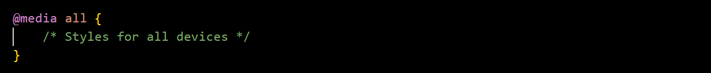

1. ***screen:***

* Styles for computer screens, tablets, and smartphones.

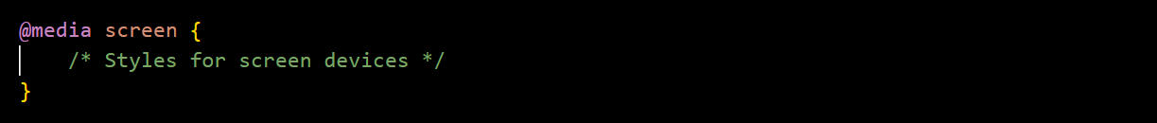

1. ***print:***

* Styles for printed pages.

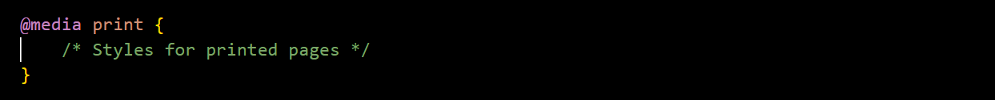

1. ***speech:***

* Styles for screen readers that "read" the page out loud.

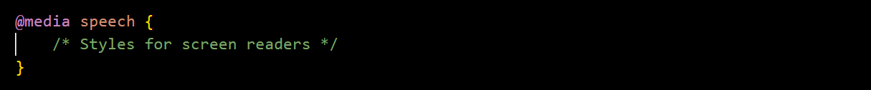

1. ***braille:***

* Styles for braille tactile feedback devices.

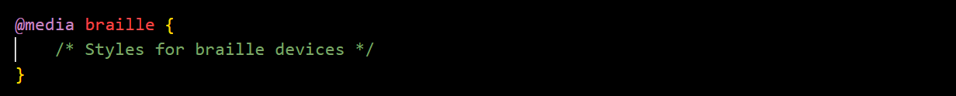

1. ***aural:***

* Deprecated and replaced by the speech media type. It was intended for speech synthesizers.



These media types can be combined or used individually to create responsive and device-specific styles. For example, you might use @media screen and (min-width: 600px) to apply styles specifically for screens with a minimum width of 600 pixels.

Here's an example of using a media query for screens with a maximum width of 800 pixels:

This media query adjusts the font size for screens with a width of 800 pixels or less. Media queries are a powerful tool for creating responsive and adaptable designs that cater to different devices and user preferences.

**(Q.19) What is the rule set?**

**(ANS):**

In CSS (Cascading Style Sheets), a rule set consists of a selector and a declaration block. The selector defines which HTML elements the styles should apply to, and the declaration block contains one or more declarations that specify the styles for the selected elements. The basic syntax of a rule set is as follows:

* **Selector:** Identifies the HTML elements to which the styles will be applied. It can be an HTML element name, a class, an ID, or a combination of these.
* **Declaration Block:** Enclosed in curly braces {}, contains one or more property-value pairs separated by semicolons. Each property-value pair defines a specific style rule.

Here's a simple example of a CSS rule set:

In this example:

* The selector is h1, indicating that the styles will apply to all <h1> elements in the HTML document.
* The declaration block contains two declarations: color: blue; and font-size: 24px;. These declarations specify the text color and font size for the selected <h1> elements.

Multiple rule sets can be combined to create a complete set of styles for a web page. For example:

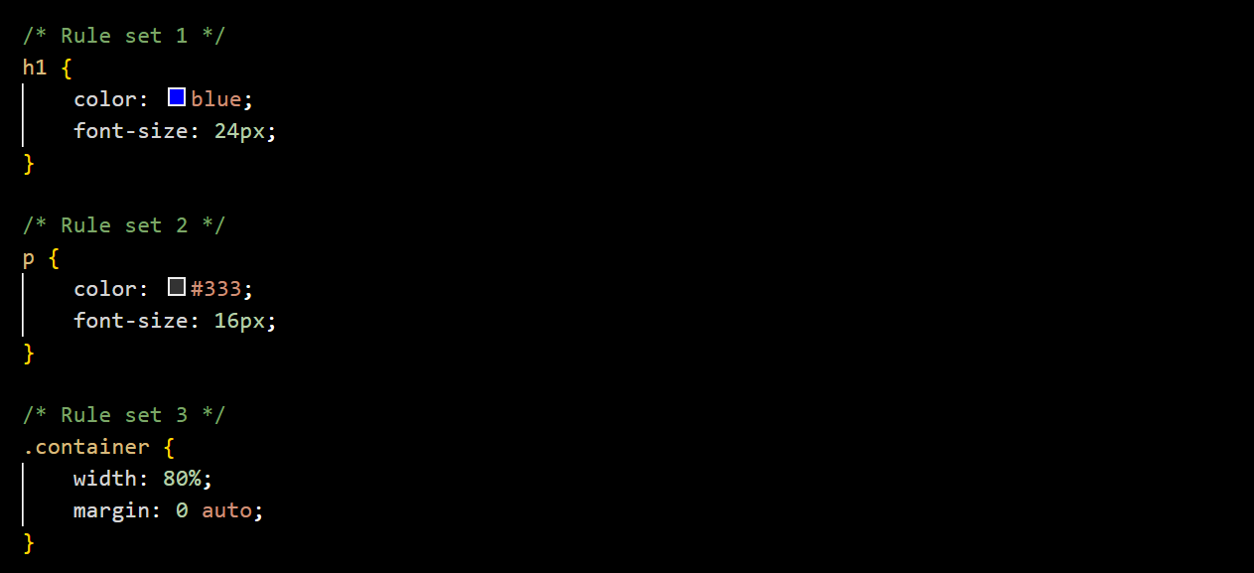

In this example:

* The first rule set styles <h1> elements.
* The second rule set styles <p> elements.
* The third rule set styles elements with the class "container."

Together, these rule sets contribute to the overall styling of the HTML document. The cascading nature of CSS allows styles to be applied based on specificity, importance, and source order, resulting in a coherent and visually appealing presentation of the content.